**WEB TECHNOLOGY ASSIGNMENT**

**1. Write a Javascript Program to perform the following operations**

**Find the Sum of all the integers which are divisible by 3 between 1 to 1000.**

<!DOCTYPE html>

<html lang="en">

<head>

    <meta charset="UTF-8">

    <meta http-equiv="X-UA-Compatible" content="IE=edge">

    <meta name="viewport" content="width=device-width, initial-scale=1.0">

    <title>Document</title>

    <link rel="stylesheet" href="style.css">

</head>

<body>

    <h1 id="title">Sum of integers which are divisible by 3 between 1 to 1000</h1>

    <div class="center">

    <br><br>

    <form id="loginform" >

        <br><br>

        <label class="txt_field"  >Enter No 1:</label>

        <input class="txt_field" type="number" id="a">

        <br><br>

        <label class="txt_field" >Enter No 2:</label>

        <input type="number" id="b" >

        <br><br>

        <input class="subbtn" type="button" value="CLick"  onclick="divsum()">

        <br><br>

        <label class="txt_field"  >Answer:</label>

        <input readonly type="number" value="0" id="output">

        <br><br>

    </form>

</div>

    <script>

        function divsum(){

        var a, b, i;

        a = document.getElementById("a").value

        b = document.getElementById("b").value

        console.log("a :"+a)

        console.log("b :"+b)

        var sum=0;

        for (i = a; i <= b; i++) {

        if (i % 3 == 0) {

            sum=sum+i;

        }

        }

        document.getElementById("output").value=sum;

    }

    </script>

</body>

</html>

**Style.css**

@import url('https://fonts.googleapis.com/css2?family=Noto+Sans:wght@700&family=Poppins:wght@400;500;600&display=swap');

*{

    margin: 0;

    padding: 0;

    box-sizing: border-box;

    font-family: "Poppins", sans-serif;

  }

  body

{

    margin: 0;

    padding: 0;

    font-family: montserrat;

    background: linear-gradient(120deg, #2980b9,#8e44ad);

    height: 100vh;

    overflow: hidden;

}

input

{

    box-sizing: border-box;

     border: 3px solid #ccc;

}

  .center

  {

      position: absolute;

      top: 50%;

      left: 50%;

      transform: translate(-50%,-50%);

      width:400px;

      background: white;

      border-radius: 10px;

  }

  .center h1

  {

      text-align: center;

      padding:20px 0;

      border-bottom: 1px solid silver;

  }

  .center form

{

    padding: 0 40px;

}

.subbtn

{

    width: 50%;

    margin-left: 20%;

    margin-right: auto;

    height: 50px;

    border: 1px solid;

    background: #2691d9;

    border-radius: 25px;

    font-size: 18px;

    color: #e9f4fb;

    font-weight: 700;

    cursor:pointer;

}

.subbtn:hover

{   border-color: #2691d9;

    transition: .5s;

}

#title

{   margin-top: 100px;

    text-align: center;

    color: white;

}

**Output**

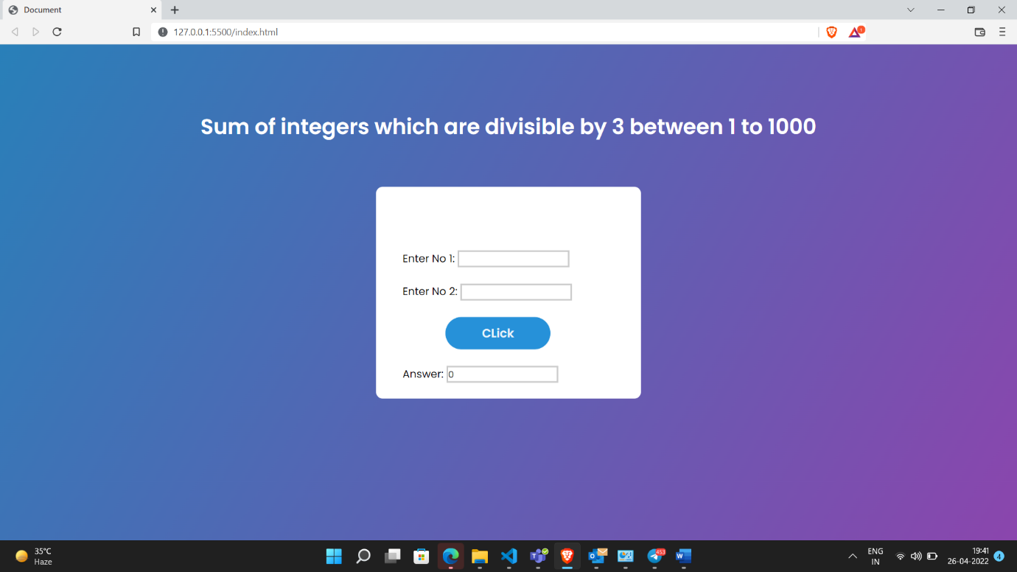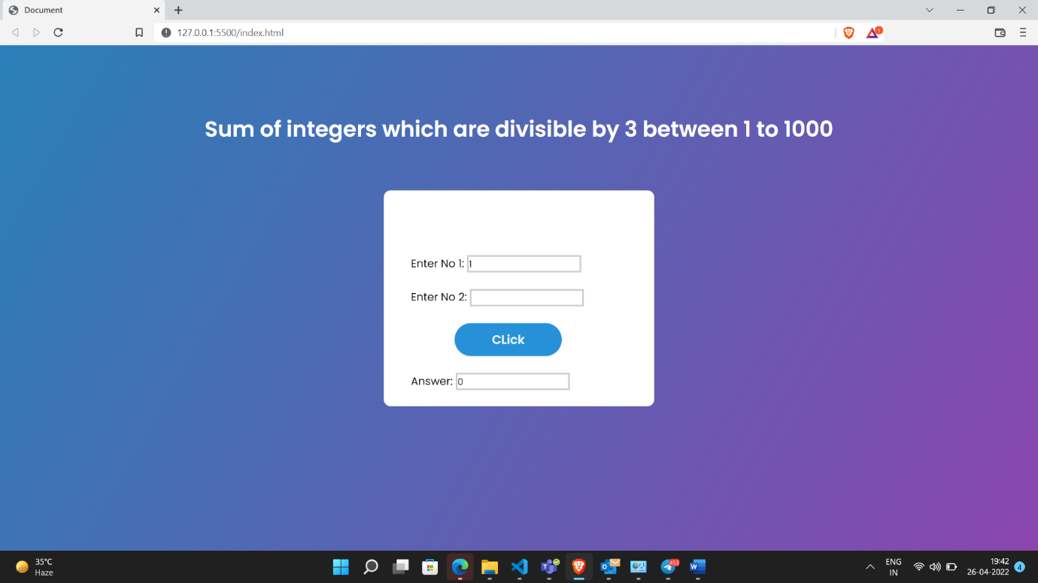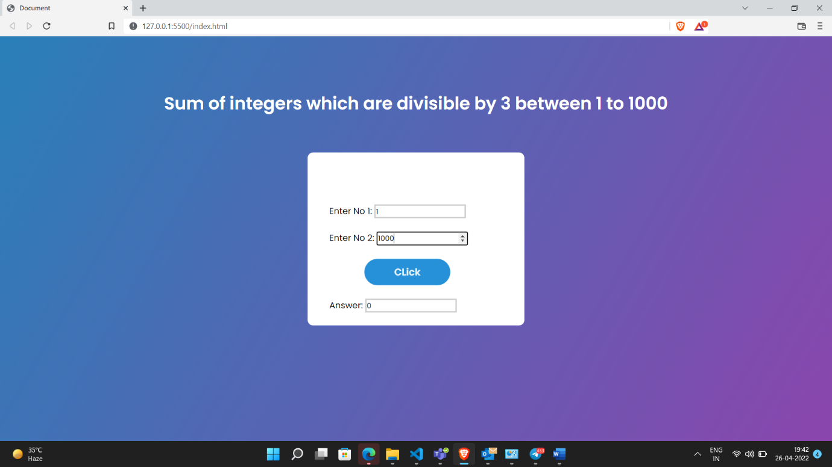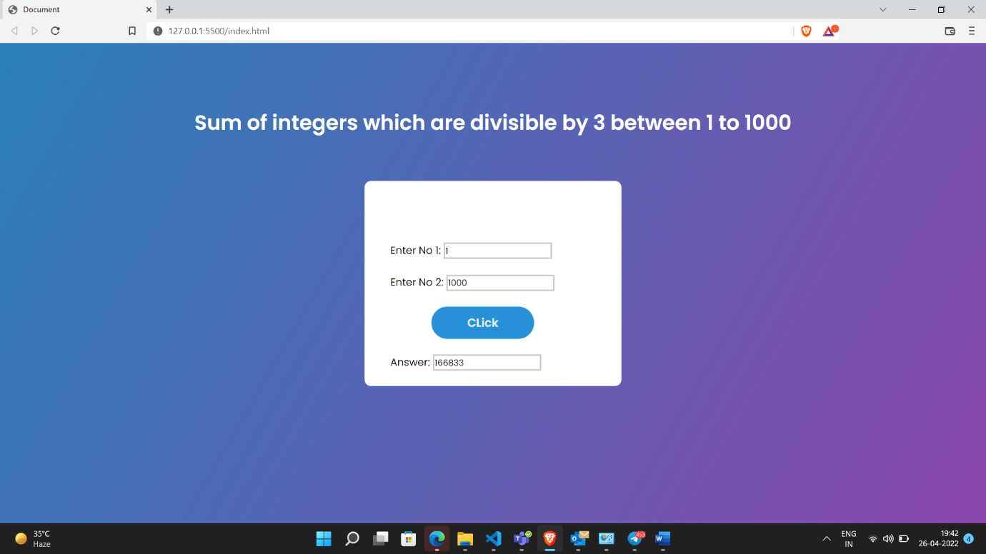

**Find the Sum of odd integers which are divisible by 5 between 1 to 1000.**

<!DOCTYPE html>

<html lang="en">

<head>

    <meta charset="UTF-8">

    <meta http-equiv="X-UA-Compatible" content="IE=edge">

    <meta name="viewport" content="width=device-width, initial-scale=1.0">

    <title>Document</title>

    <link rel="stylesheet" href="style.css">

</head>

<body>

    <h1 id="title">Sum of all the odd integers which are divisible by 5 between 1 to 1000.</h1>

    <div class="center">

    <br><br>

    <form id="loginform" >

        <br><br>

        <label class="txt_field"  >Enter No 1:</label>

        <input class="txt_field" type="number" id="a">

        <br><br>

        <label class="txt_field" >Enter No 2:</label>

        <input type="number" id="b" >

        <br><br>

        <input class="subbtn" type="button" value="CLick"  onclick="divsum()">

        <br><br>

        <label class="txt_field"  >Answer:</label>

        <input readonly type="number" value="0" id="output">

        <br><br>

    </form>

</div>

    <script>

        function divsum(){

        var a, b, i;

        a = document.getElementById("a").value

        b = document.getElementById("b").value

        console.log("a :"+a)

        console.log("b :"+b)

        var sum=0;

        for (i = a; i <= b; i++) {

        if (i % 2 == 1 && i%5==0) {

            sum=sum+i;

        }

        }

        document.getElementById("output").value=sum;

    }

    </script>

</body>

</html>

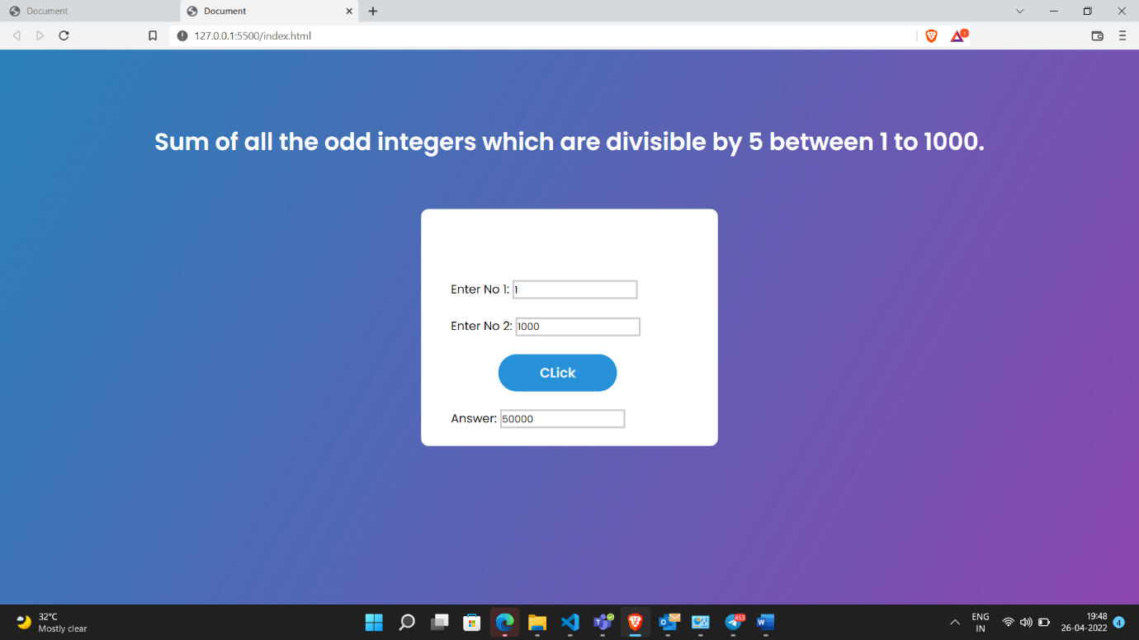

**2) Create a XML document consisting of details of employees in an organization . Validate the document using Schema**

**Employee.xml**

<?xml version="1.0" encoding="UTF-8"?>

<?xml-stylesheet type='text/xsl' href='Employee.xsl'?>

<employeedetails>

<details>

<name>Arun</name>

<age>65</age>

<position>Manager</position>

<salary>100000</salary>

</details>

<details>

<name>Arul</name>

<age>21</age>

<position>Executive</position>

<salary>50000</salary>

</details>

<details>

<name>Ram</name>

<age>32</age>

<position>Frontend Developer</position>

<salary>50000</salary>

</details>

<details>

<name>Varun</name>

<age>35</age>

<position>Backend Developer</position>

<salary>50000</salary>

</details>

<details>

<name>Shyam</name>

<age>28</age>

<position>FullStack Developer</position>

<salary>70000</salary>

</details>

<details>

    <name>Ravi</name>

    <age>40</age>

    <position>Program Analyst</position>

    <salary>80000</salary>

    </details>

</employeedetails>

**Employees.xsl**

<?xml version="1.0" encoding="UTF-8"?>

<xsl:stylesheet version="1.0" xmlns:xsl="http://www.w3.org/1999/XSL/Transform">

<xsl:template match="/">

<html>

<body style="background-color:rgb(248, 216, 167)">

<h1 style="text-align:center; margin-top:150px;">Employee Details</h1>

<h3 style="text-align:center; margin-top:20px;">(Whose age is greater than 30)</h3>

  <table border="8" cellpadding="15"

          style="font-weight: bold; background-color:white;margin-top:50px;" align="center" >

  <tr style="background-color:rgb(255, 175, 55)">

    <th style="padding:30px;">Name</th>

    <th>Age</th>

    <th>Position</th>

    <th>Salary</th></tr>

<xsl:for-each select="employeedetails/details">

<xsl:if test="age>30">

      <tr>

        <td><xsl:value-of select="name"/></td>

        <td><xsl:value-of select="age"/></td>

        <td><xsl:value-of select="position"/></td>

        <td><xsl:value-of select="salary"/></td>

      </tr>

    </xsl:if>

</xsl:for-each>

</table>

</body>

</html>

</xsl:template>

</xsl:stylesheet>

